 |  |  | udemystudent151113 |  |  |  |  |  | Export KUBECONFIG=/etc/kubernetes/admin.config  --kubeconfig=filename  To ssh in node --> ssh -i id_rsa lucky@172.30.64.102
ssh -i .\test-vm_key.pem azureuser@104.47.154.172

k exec -it busybox-deployment-5cb8fc5b7-z6wzh sh
k top node --->
kubectl top node --sort-by='cpu' --no-headers | head -1 --> to determine which node with high cpu

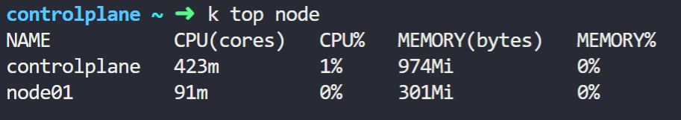

IF you need to exec cat file in pod in another namespace
kubectl -n elastic-stack exec -it app -- cat /log/app.log
POD
1- k get po --watch
2- k run nginx --image=nginx
3- K get po -o wide
4- k delete po name
5 k get po -A
Replicaset
1- k get replicaset or k get rs
2- k explain rs | grep VERSION
3-kubectl scale rs new-replica-set --replicas=5

 | Deployment:  1- k get deploy Or k get deployment  2-k explain deploy | head -n1  3- k create deploy webapp --imagekodekloud/webapp-color --replicas=3  To upgrade:  Kubectl set image deployment/name nginx=nginx:19.1.0 |  | Namespaces  1- k get ns Or k get namspaces  2-k get po -n name Or k get po --namespace name  3-k create deploy redis-deploy --image=redis --replicas 2 -n dev-ns  4-

Services
1- k get svc Or k get service
2- -k create svc clusterip--> k expose pod redis --port=6379 --name redis-service
- K expose deployment hr-web --name service --type NodePort --port 8080

kubectl expoapiVersion: v1

kind: Service

metadata:

name: example-service

spec:

selector:

app: example

ports:

- port: 8765

targetPort: 9376

type: LoadBalancer
se deployment <deployment-name> --type=LoadBalancer --port=<port-number> --target-port=<target-port-number> --dry-run=client -o yaml > service.yaml

httpd' service exposes the 'httpd' pod?
3- k run httpd --image httpd:alpine --port 80 --expose
- Kube-api-server --service-cluster-ip-range ipNet
lw 3aeiz t3rf range al kube-proxy , bykon by default (10.0.0.0)

- Iptables -L -t nat | grep db-services --> any traffic going to the ip address ba nat 3la anhy ip
- Cat /var/log/kube-proxy.log

7-What is the IP Range configured for the services within the cluster?
-
cat /etc/kubernetes/manifests/kube-apiserver.yaml | grep cluster-ip-range
Imperative way
1-k run redis --image=redis:alpine --labels "tier=db"
2-k create svc clusterip--> k expose pod redis --port=6379 --name redis-service (create service for existed pod in cluster )-

- k run custom-nginx --image nginx --port=8080

Selectors
to show how many label with tier=env in namespace =dev :
1- k get po --selectors env(label)=dev(ns) --no-headers | wc -l
to get all object in prod environment :
2-k get all --selectors env=prod (ns)

Manual Schceduling
1- use "nodeName" to select node
1 - k replace --force -f nginx.yaml
To get pods with Selector
1-k get po --selector env=dev --no-headers | wc -l

2-k get all --selector env=prod
3-kubectl get all --selector env=prod,bu=finance,tier=frontend(lw 3aeiz ageb al comman pod maben namepace mo3yn )

Taints & Tolerations
1- k taint node node01 spary(key)=mortein(Value):NoSchedule(Effect)

To remove a taint : kubectl taint node control plane taints - dash
Label
kubectl label node node01 color=blue

Daemonsets
1-k get daemonsets --all-namespaces
2- k get daemonsets kube-proxy -n kube-system
3- kubectl describe daemonset kube-flannel-ds --namespace=kube-flannel
to create a Daemonsets :
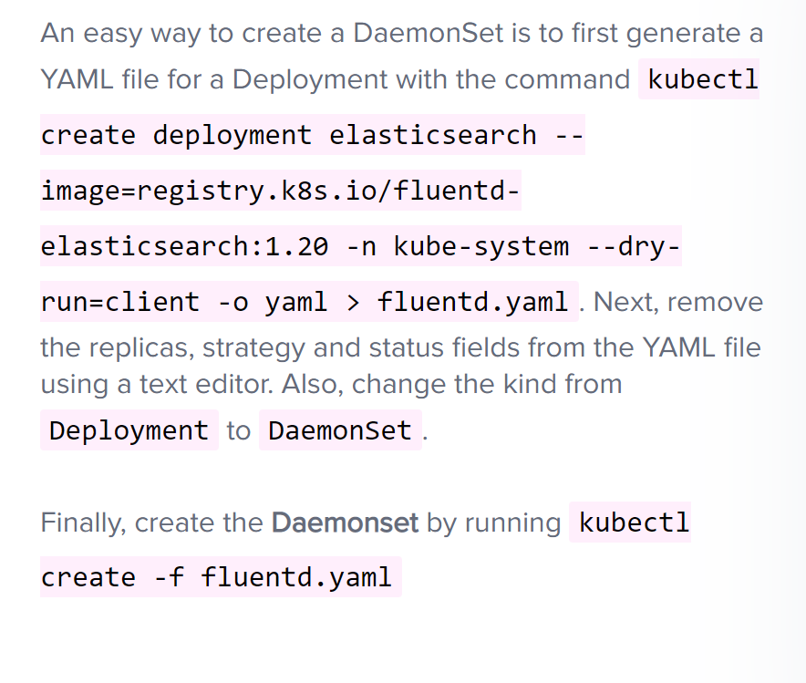
Multiple Schedulers
1- to know which scheduler is piked up in cluster --> k logs pod(name) , k events -o wide

StaticPod
How to delete static pod : ?
- we need to find the manifest file and delete it :
1- get internal ip of the node that have the static pod by this command --> k get node -o wide
2- ssh on node --> ssh Internal ip
3- cat /var/lib/kubelet/config.yaml
4- search on staticPodPath
5-rm (file )

2 -
kubectl run --restart=Never --image=busybox static-busybox --dry-run=client -o yaml --command -- sleep 1000 > /etc/kubernetes/manifests/static-busybox.yaml
ClusterRoleBinding :
kubectl get clusterrolebinding
ServiceAccount :
A service account provides an identity for processes that run in a Pod, and maps to a ServiceAccount object.
1- k get serviceaccount -n kube-system
Configmap: environment variable in applications used when you have a lot of pod definition files , it will become difficult to manage the environment data stored within quires files so we can manage it by using configuration maps
1- k create configmap my-scheduler-configmap.yaml --from-file=/root/my-scheduler-config.yaml -n kube-system (create configmap from existing file )
2-
kubectl create configmap my-config --from-literal=key1=config1 --from-literal=key2=config2 -->k create configmap webapp-config-map --from-literal=APP_COLOR=darkblue --from-literal=APP_OTHER=disregard
3- how to add configmap to pod
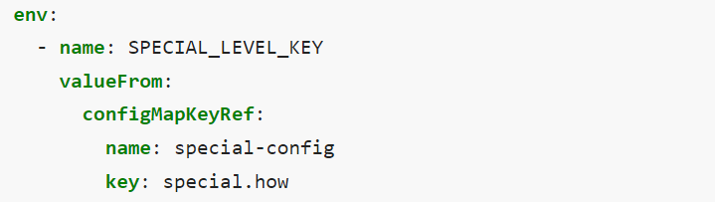
Definitionfile:
A POD definition file is given. Use it to create a POD with the new custom scheduler.?
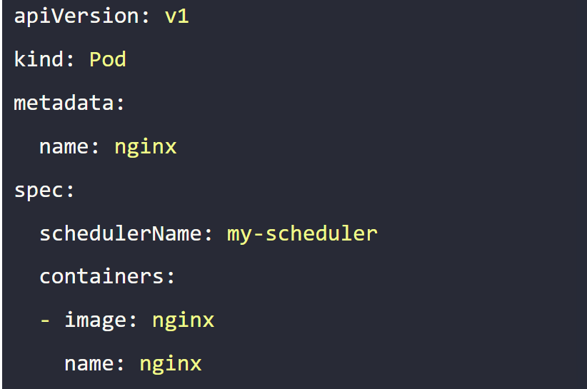

Container Interface Network (CNI)
1 - Inspect the kubelet service and identify the container runtime endpoint value is set for Kubernetes
- ps aux | grep kubelet | grep --color container-runtime-endpoint
- ps aux | grep kubelet | grep network
2-What is the path configured with all binaries of CNI supported plugins?
- /opt/cni/bin
3- What is the CNI plugin configured to be used on this kubernetes cluster
/etc/cni/net.d/
- What binary executable file will be run by kubelet after a container and its associated namespace are created? cat /etc/cni/net.d/
DNS
to get pods to resolve each other
1- local file ---> /etc/hosts
- /etc/nsswitch.conf --> lw 3aeiz a5leh yro7 ybos 3la al dns server al awl (resolve.config) w b3d kda yro7 lel hosts file
3-DNS resolution configuration file --> /etc/resolve.conf (this is the file where we configure DNS Server )
CoreDns (configuration file of dns )--> /etc/coredns/corefile , if we need to modify this configuration file we can edit the configmap
Ingress :
1- kubectl get ingress --all-namespaces

2-kubectl create ingress <ingress-name> --rule="host/path=service:port" -->ex--> kubectl create ingress ingress-pay -n critical-space --rule="/pay=pay-service:8082"
3- k describe ingress -n app-space
4-

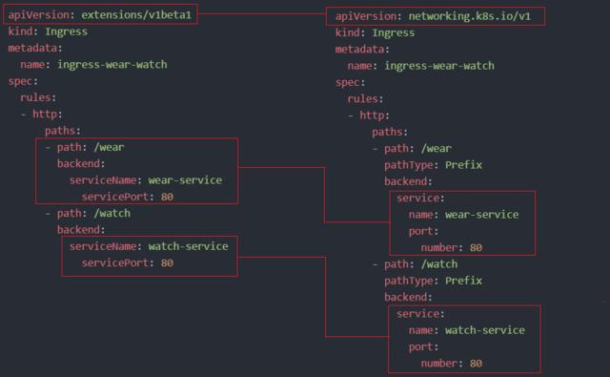
Annotations
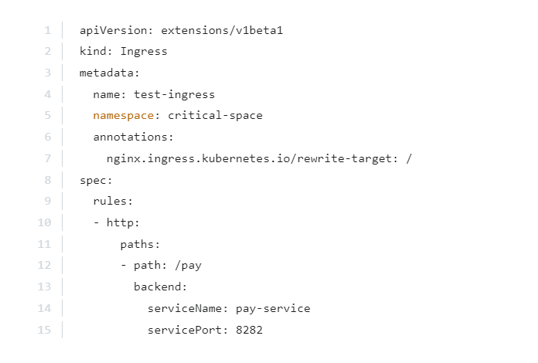
nginx.ingress.kubernetes.io/rewrite-target: / ---> optional
Command & args
1-to create pod with command (like enterypoint indocker)
k run name --image --command color red

2-to create pod with argument (cmd )
k run webapp-green --image kodekloud/webapp-color -- color green
Secret : type of environment variable used to store sensitive information , it's similar to configmap except they're stored in a encoded format (not encrypted )

kubectl create secret generic db-secret --from-literal=DB_Host=sql01 --from-literal=DB_User=root --from-literal=DB_Password=password123

- K create secret generic --help

- To add secret to pod

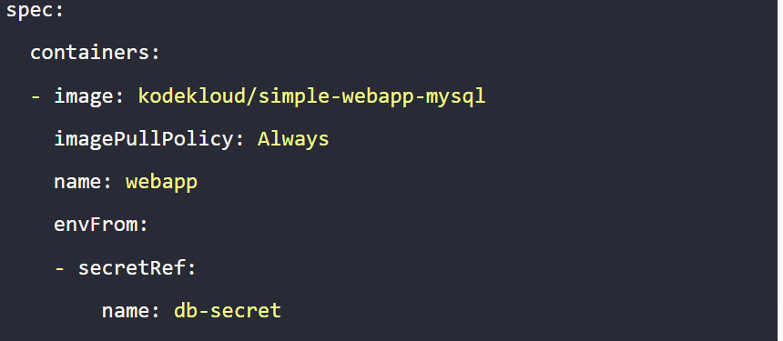
Init container
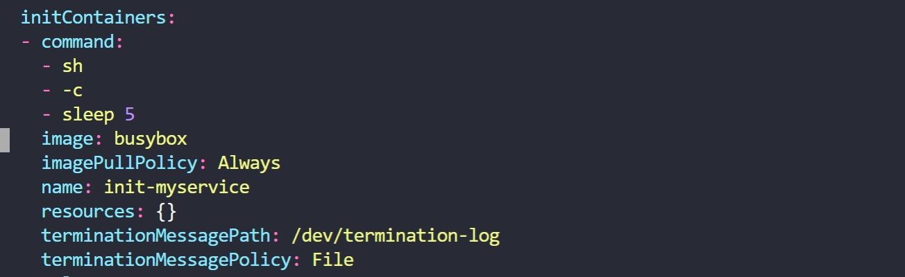
Drain
1- kubectl drain node01 --ignore-daemonsets
2-k uncordon node01
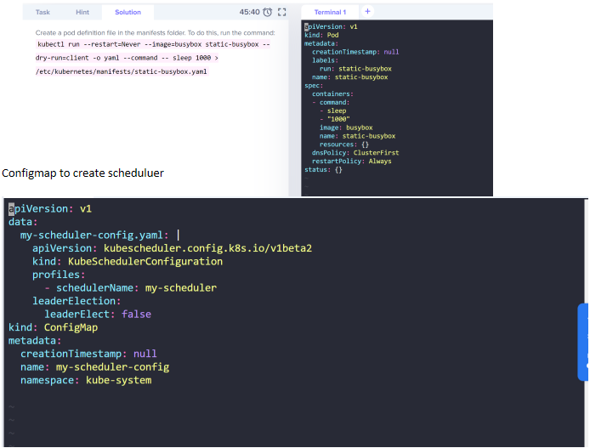
Configfile path:
3lashan nshof
=============================
Nodes
$ kubectl get no
$ kubectl get no -o wide
$ kubectl describe no
$ kubectl get no -o yaml
$ kubectl get node –select or =[ label _name]
$ kubectl get nodes -o jsonpath=’{.items[*].status.addresses[?(@.type==”ExternalIP”)].address}’
$ kubectl top node [node_name]
Pods
$ kubectl get po
$ kubectl get po -o wide
$ kubectl describe po
$ kubectl get po –show-labels
$ kubectl get po -l app=nginx
$ kubectl get po -o yaml
$ kubect l get pod [ pod_name] -o yaml –export
$ kubect l get pod [pod_name] -o yaml –export > nameoffile.yaml
$ kubectl get pods –field-selector status.phase=Running
Namespaces
$ kubectl get ns
$ kubectl get ns -o yaml
$ kubectl describe ns
Deployments
$ kubectl get deploy
$ kubectl describe deploy
$ kubectl get deploy -o wide
$ kubectl get deploy -o yaml
Services
$ kubectl get svc
$ kubectl describe svc
$ kubectl get svc -o wide
$ kubectl get svc -o yaml
$ kubectl get svc –show-labels
DaemonSets
$ kubectl get ds
$ kubectl get ds –all-namespaces
$ kubectl describe ds [daemonset _name] -n [namespace_name]
$ kubectl get ds [ds_name] -n [ns_name] -o yaml
Events
$ kubectl get events
$ kubectl get events -n kube-system
$ kubectl get events -w
Logs
$ kubectl logs [pod_name]
$ kubectl logs –since=1h [pod_name]
$ kubectl logs –tail =20 [pod_name]
$ kubectl logs -f -c [container_name] [pod_name]
$ kubectl logs [pod_name] > pod.log
Service Accounts
$ kubectl get sa
$ kubectl get sa -o yaml
$ kubectl get serviceaccounts default -o yaml > ./sa.yaml
$ kubectl replace serviceaccount default -f. /sa.yaml
ReplicaSets
$ kubectl get rs
$ kubectl describe rs
$ kubectl get rs -o wide
$ kubectl get rs -o yaml
Roles
$ kubectl get roles –all-namespaces
$ kubectl get roles –all-namespaces -o yaml
Secrets
$ kubectl get secrets
$ kubectl get secrets –all-namespaces
$ kubectl get secrets -o yaml
ConfigMaps
$ kubectl get cm
$ kubectl get cm –all-namespaces
$ kubectl get cm –all-namespaces -o yaml
Ingress
$ kubectl get ing
$ kubectl get ing –all-namespaces
PersistentVolume
$ kubectl get pv
$ kubectl describe pv
PersistentVolumeClaim
$ kubectl get pvc
$ kubectl describe pvc
StorageClass
$ kubectl get sc
$ kubectl get sc -o yaml
MultipleResources
$ kubectl get svc, po
$ kubectl get deploy, no
$ kubectl get all$ kubectl get all –all-namespaces
Changing Resource Attributes
Taint
$ kubectl taint [node_name] [taint _name]
Labels
$ kubectl label [node_name] disktype=ssd
$ kubrectl label [pod_name] env=prod
Cordon/Uncordon
$ kubectl cordon [node_name]
$ kubectl uncordon [node_name]
Drain
$ kubectl drain [node_name]
Nodes/Pods
$ kubectl delete node [node_name]
$ kubectl delete pod [pod_name]
$ kubectl edit node [node_name]$ kubectl edit pod [pod_name]
Deployments/Namespaces
$ kubectl edit deploy [deploy_name]
$ kubectl delete deploy [deploy_name]
$ kubectl expose deploy [depl oy_name] –port=80 –type=NodePort
$ kubectl scale deploy [deploy_name] –replicas=5
$ kubectl delete ns$ kubectl edit ns [ns_name]
Services
$ kubectl edit svc [svc_name]
$ kubectl delete svc [svc_name]
DaemonSets
$ kubectl edit ds [ds_name] -n kube-system
$ kubectl delete ds [ds_name]
ServiceAccounts
$ kubectl edit sa [sa_name]
$ kubectl delete sa [sa_name]
Annotate
$ kubectl annotate po [pod_name] [annotation]
$ kubectl annotate no [node_name]
Adding Resources Creating a Pod
$ kubectl create -f [name_of _file]
$ kubectl apply -f [name_of _file]
$ kubectl run [pod_name] –image=ngi nx –restart=Never
$ kubectl run [ pod_name] –generator =run-pod/v1 –image=nginx
$ kubectl run [ pod_name] –image=nginx –restart=Never
Creating a Service
$ kubectl create svc nodeport [svc_name] –tcp=8080:80
Creating a Deployment
$ kubectl create -f [name_of _file]
$ kubectl apply -f [name_of _file]
$ kubectl create deploy [deploy_name] –image=ngi nx
Interactive Pod
$ kubectl run [pod_name] –image=busybox –rm -it –restart=Never — sh
Output YAMLto aFile
$ kubectl create deploy [deploy_name] –image=ngi nx –dry-run -o yaml > deploy.yaml
$ kubectl get po [pod_name] -o yaml –export > pod. yaml
Getting Help
$ kubectl -h$ kubectl create -h
$ kubectl run -h
$ kubectl explain deploy.spec
Requests API Call
$ kubectl get –raw /apis/metrics.k8s.io/
Cluster Info
$ kubectl config
$ kubectl cluster -info
$ kubectl get componentstatuses

From <https://medium.com/@AnnAfame/kubernetes-cheat-sheet-94ccb0432a01>
=========================================================
ingress
CNI (container network interface) : ka2no middle man ba run script automatically when pod Is created badl ma nro7 la kol pod na assign al network bta3tha manually , Kubelet looks at CNI configurations when it is run and identifies our script's name , and the looks in CNI's bin directory to find our script and then execute the script
Ingress : ingress help us to access applications using a single externally accessible URL that you can configure to route traffic to different services using based on URL path
At the same time , also implement ssl security as well

- EVEN ingress you need to expose it to make it accessible outside the cluster (we need node port OR Cloud-native load balancer )

- Type of ingress controller (nginx , Haproxy ,Traefik, contiour , istio)
- Ingress controller is deploy as just another Deployment in kuberentes
There are two types :
1- ingress controller : you must deploy ingress controller firstly then configure it using ingress(configuration file )

In ingress controller you must specify :

Configmap : we decouple this configuration data from the nginx controller image so you must create configmap to
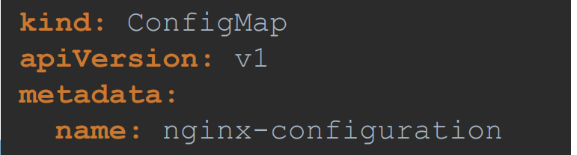

- to store location of ingress controller
- Args(location) : path to store the logs
- SsL settings ,,,cetera

- Ingress controller must also pass in two environment variables that carry the pod's name & namespace it deployed to
- Finally specify the ports used by the ingress controller , which happens to be 80 and 443
  - 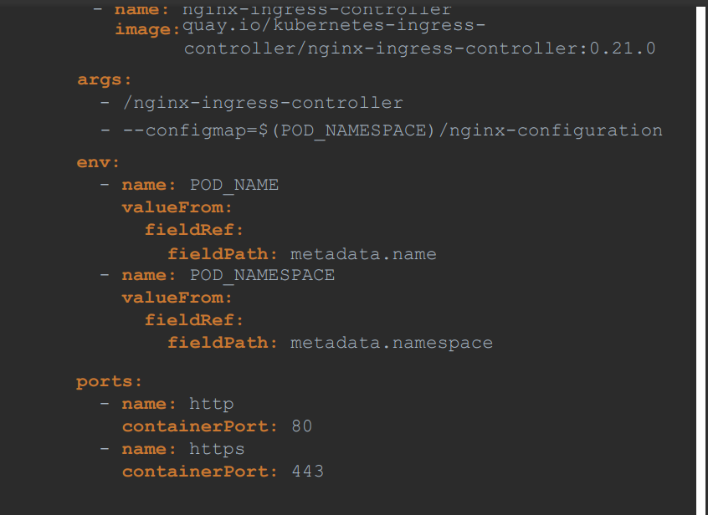

c.Then need a service to expose the ingress controller to external world
Also we need serviceaccounts with the right permission to access all of these object
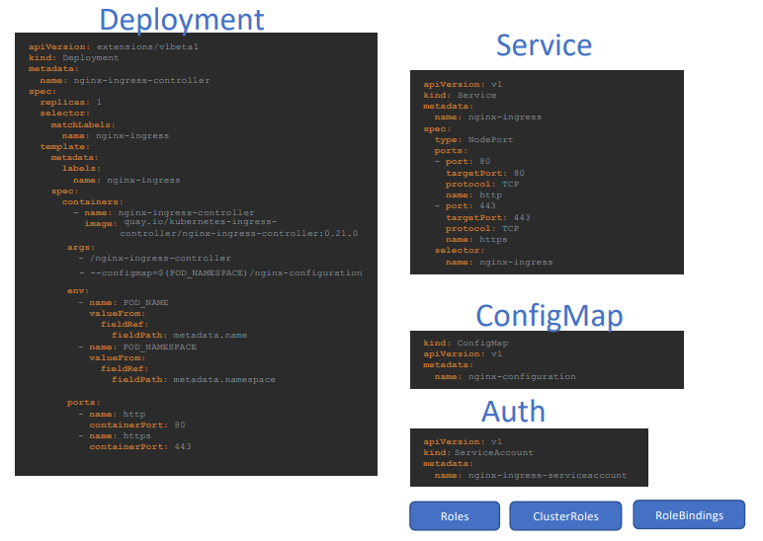

- Ingress Resources (set of rules): are created using definitions file (like pods , deployments ,service account )
It's a set of rules and configurations applied on the ingress controller
Note : kubernetes cluster doesn't come with ingress controller
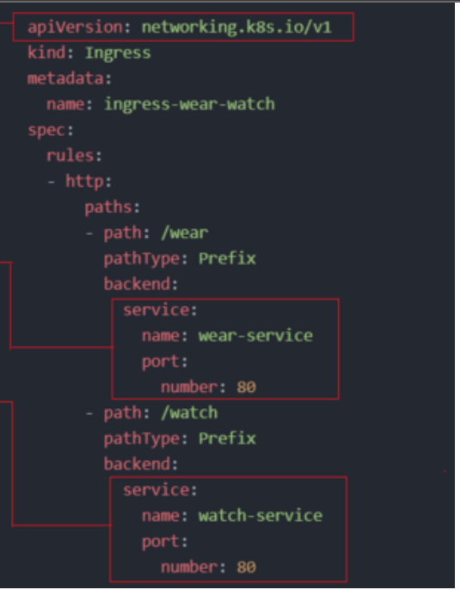

INGRESS

apiVersion: networking.k8s.io/v1
kind: Ingress
metadata:
name: test-ingress
namespace: critical-space
annotations:
nginx.ingress.kubernetes.io/rewrite-target: /
nginx.ingress.kubernetes.io/ssl-redirect: "false"
spec:
rules:
- http:
paths:
- path: /pay
pathType: Prefix
backend:
service:
name: pay-service
port:
number: 8282
==============================command2===========================
mkdir -p ~/.kube/
touch ~/.kube/config
Kubctl config view
Kubectl config view --kubeconfig=my-custom-config
Kubectl config -h
- to move from cluster to another :
kubectl config use-context cluster1

-to check if there external etcd :
1-Ssh on node then run
ps -ef | grep etcd or you can see the same info from kube-api server
- kubeadm token create --print-join-command ---> Get the join command from the master node

2-kubectl config view --raw > kubeconfig.yaml > This will save the config file to a file named kubeconfig.yaml.

Set the KUBECONFIG environment variable ----> $env:KUBECONFIG="C:\path\to\kubeconfig.yaml"
To exec on a pod and cat file : ---> kubectl exec webapp -- cat /log/app.log

